SQL Express Database Restore Procedure

During a scheduled Paintworks Automatic Backup, backups of the SQL Server Express databases are created and placed in a backup folder. For example in the Basecoat A zone, backups of the databases that reside in the “C:\Paint\Database\Basecoat A” folder are placed in the “C:\Paint\Database\Basecoat A\Backup folder”. Subsequently when the entire Paint folder is backed up to the D:\ drive, some of the SQL Server Express database files cannot be copied because they are in use. For these databases, the backup files can be used if a database must be recovered. The procedure below can be used to recover a database from a backup file using the “Microsoft SQL Server Management Studio Express” console.

1.) Right-click "Databases" in the Object Explorer tree view and choose "Restore Database..." from the context menu. The "Restore Database" dialog will pop up.

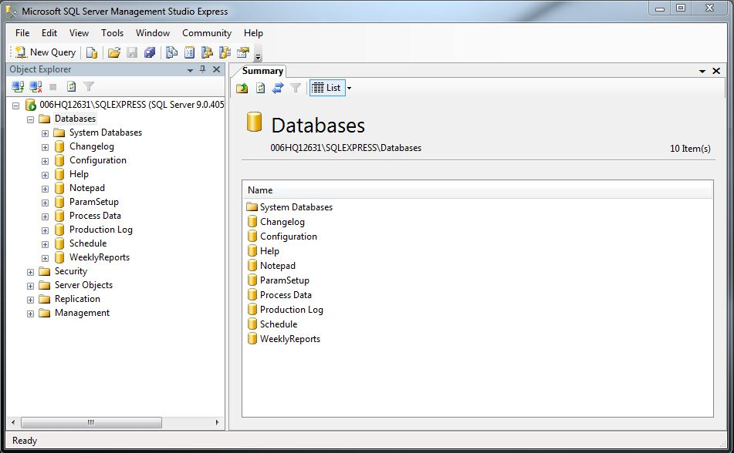

2.) Type the name of the database (in this case "Alarm Log") into the "To Database" field of "Destination for restore". Then, select the "From device:" radio button from the "Source for restore"" area. Click the [...] button to show the "Specify Backup" dialog.

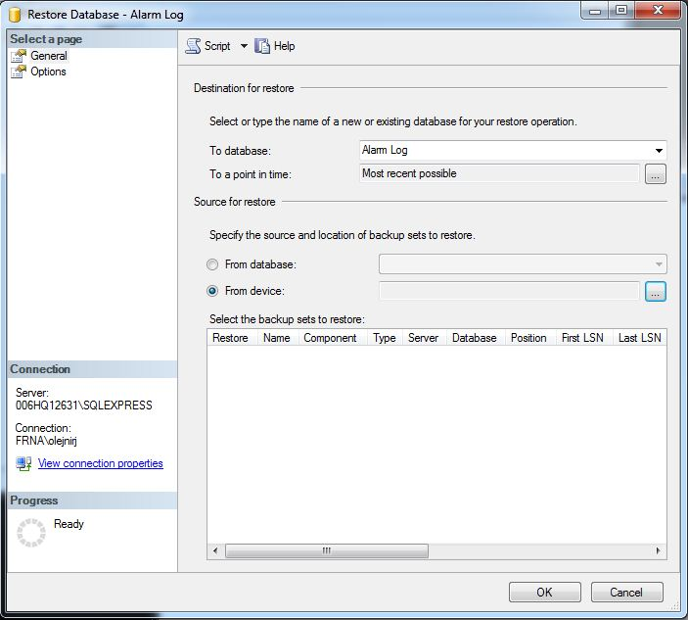

3.) Click the "Add" button. The "Locate Backup File" dialog (shown below) will pop up.



4.) Browse to the location of the backup file (in this case C:\Paint\Database\Basecoat B\Backup\dbo.alarm log.bak) and click the "OK" button. This will return you to the "Specify Backup" dialog. Then, click the "OK" button to return to the "Restore Database" dialog.

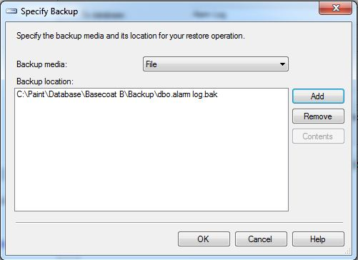

5.) Check the checkbox in the "Restore" column of the "Select the backup sets to restore:" list then click the "OK" button to begin the restore process.

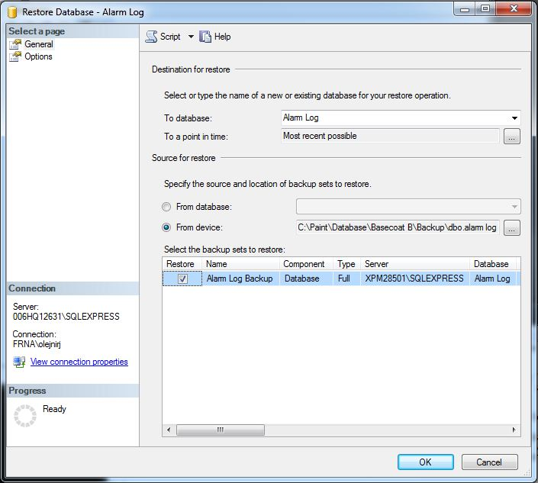

6.) When the restoration is complete, a box will pop up to indicate that it was successful. Click the "OK" button.

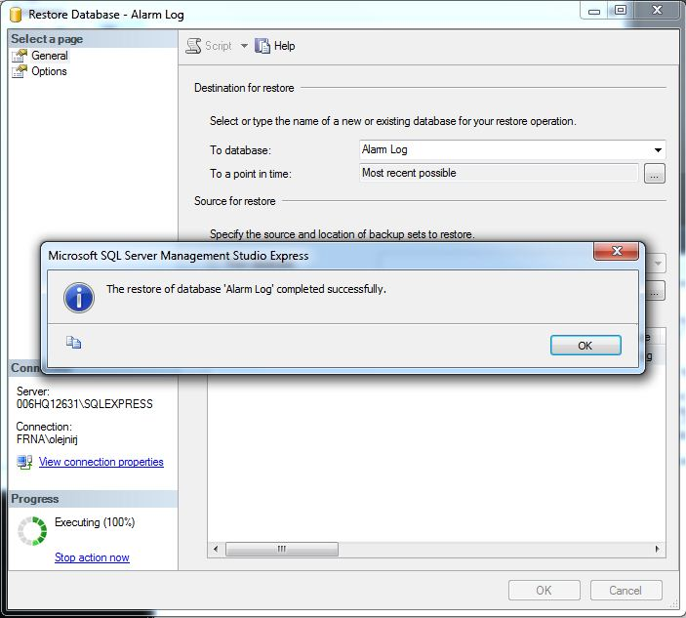

7.) The restored database(s) will now appear in the list of databases.

